Tandem Patient Reported Outcomes (PROs)

Kristen Campbell

September 9, 2019

##Summary Stats **Table 1: Patient Demographics - By Method**

|  |  |  |  |  |
| --- | --- | --- | --- | --- |
| Characteristic | Injections (n=82) | Non-Tandem Pump (n=159) | Tandem Pump (n=300) | P Value |
| **Respondent Type** |  |  |  | 1e-04 |
| A Parent/Guardian/Caregiver of someone with Diabetes | 28 (34%) | 20 (13%) | 50 (17%) |  |
| Person with Diabetes | 54 (66%) | 139 (87%) | 250 (83%) |  |
| **** | 31.12Â±18.85 | 38.09Â±15.16 | 37.56Â±16.96 | 0.0044 |
| **Duration of diabetes at baseline (years)** | 10.55Â±13.34 | 22.91Â±12.9 | 19.87Â±14.37 | <0.0001 |
| **HbA1c at baseline** | 7.51Â±1.49 | 7.18Â±1.01 | 7.03Â±1.02 | 0.0021 |
| **Any previous CGM use?**\*\* |  |  |  | <0.0001 |
| No | 13 (16%) | 9 (6%) | 5 (2%) |  |
| Yes | 69 (84%) | 150 (94%) | 295 (98%) |  |

##Missing Data **Table 2a: Survey Missing Data**

|  |  |
| --- | --- |
| Characteristic | All (n=1061) |
| **Baseline fully completed** | 985 (93%) |
| **2mo fully completed** | 446 (42%) |
| **4mo fully completed** | 547 (52%) |
| **6mo fully completed** | 658 (62%) |
| **All time points Complete** | 384 (36%) |
| **In Cohort - baseline, mid-point, and 6 month complete** | 541 (51%) |

There are 541 patients that met the final inclusion criteria for the analysis. Of those 541 patients, 384 (70.98%) finished a 2 month survey, so that time point was used as the mid-point. 157 (29.02%) did not have a 2 month survey, but did have a 4 month survey, so this was used as the mid-point.

##Survey Data - plots 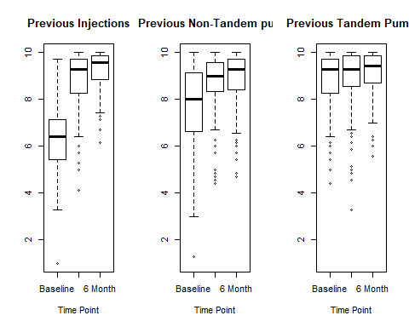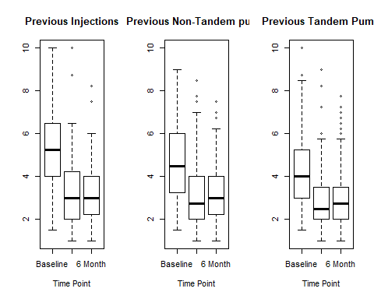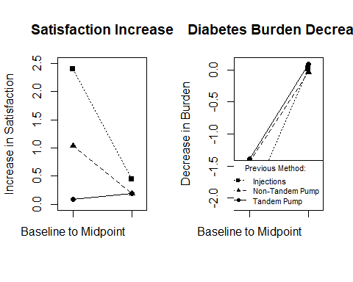 ##Survey Data - results **Table 4: Satisfaction changes, by previous method**

|  |  |  |
| --- | --- | --- |
| Previous Method | Change from Baseline to Mid-Point | Change from Mid-Point to 6 Month |
| Injections | 2.32 (Adj CI: 1.8,2.84); p=<0.001 | 0.31 (Adj CI: -0.01,0.63); p=0.063 |
| Non-Tandem Pump | 1.13 (Adj CI: 0.64,1.62); p=<0.001 | 0.02 (Adj CI: -0.28,0.33); p=1 |
| Tandem Pump | 0.18 (Adj CI: -0.28,0.64); p=1 | 0.03 (Adj CI: -0.25,0.31); p=1 |

**Table 5: Diabetes Burden changes, by previous method**

|  |  |  |
| --- | --- | --- |
| Previous Method | Change from Baseline to Mid-Point | Change from Mid-Point to 6 Month |
| Injections | -1.6 (Adj CI: -2.18,-1.02); p=<0.001 | -0.12 (Adj CI: -0.56,0.33); p=1 |
| Non-Tandem Pump | -0.91 (Adj CI: -1.46,-0.36); p=<0.001 | -0.23 (Adj CI: -0.64,0.19); p=0.58 |
| Tandem Pump | -0.89 (Adj CI: -1.4,-0.37); p=<0.001 | -0.09 (Adj CI: -0.48,0.3); p=1 |

**Table 6: Factor summary stats, by previous method**

|  |  |  |  |  |  |
| --- | --- | --- | --- | --- | --- |
| Characteristic | All (n=541) | Injections (n=82) | Non-Tandem Pump (n=159) | Tandem Pump (n=300) | P Value |
| **Baseline: Factor 1 Benefit** | 8.57 (7.14, 9.57) | 6.43 (5.46, 7.14) | 8 (6.64, 9.14) | 9.29 (8.29, 9.71) | <0.0001 |
| **Mid: Factor 1 Benefit** | 9.14 (8.57, 9.71) | 9.29 (8.32, 9.71) | 9 (8.36, 9.57) | 9.29 (8.57, 9.86) | 0.0437 |
| **6 month: Factor 1 Benefit** | 9.43 (8.57, 9.86) | 9.57 (8.89, 9.86) | 9.29 (8.43, 9.71) | 9.43 (8.71, 9.86) | 0.0381 |
| **Baseline: Factor 2 Burden** | 4.25 (3.25, 5.75) | 5.25 (4, 6.44) | 4.5 (3.25, 6) | 4 (3, 5.25) | <0.0001 |
| **Mid: Factor 2 Burden** | 2.75 (2, 3.75) | 3 (2, 4.25) | 2.75 (2, 4) | 2.5 (2, 3.5) | 0.1184 |
| **6 month: Factor 2 Burden** | 2.75 (2, 3.75) | 3 (2.25, 3.94) | 3 (2.25, 4) | 2.75 (2, 3.5) | 0.1088 |

##Supplement: **Table S1: Satisfaction changes, by previous method - DIABETICS ONLY**

|  |  |  |
| --- | --- | --- |
| Previous Method | Change from Baseline to Midpoint | Change from Midpoint to 6 Months |
| Injections | 2.28 (Adj CI: 1.71,2.84); p=<0.001 | 0.4 (Adj CI: 0.04,0.76); p=0.024 |
| Non-Tandem Pump | 0.98 (Adj CI: 0.51,1.45); p=<0.001 | 0.1 (Adj CI: -0.2,0.4); p=1 |
| Tandem Pump | 0.13 (Adj CI: -0.31,0.57); p=1 | 0.16 (Adj CI: -0.12,0.44); p=0.538 |

**Table S2: Diabetes Burden changes, by previous method - DIABETICS ONLY**

|  |  |  |
| --- | --- | --- |
| Previous Method | Change from Baseline to Mid-Point | Change from Midpoint to 6 months |
| Injections | -1.98 (Adj CI: -2.63,-1.33); p=<0.001 | 0.14 (Adj CI: -0.37,0.66); p=1 |
| Non-Tandem Pump | -1.19 (Adj CI: -1.73,-0.65); p=<0.001 | -0.08 (Adj CI: -0.5,0.35); p=1 |
| Tandem Pump | -1.16 (Adj CI: -1.68,-0.65); p=<0.001 | 0.04 (Adj CI: -0.37,0.44); p=1 |

**Table S3: Patient Demographics - Inclusion/Exclusion**

|  |  |  |  |  |
| --- | --- | --- | --- | --- |
| Characteristic | All (n=1061) | 0 (n=520) | 1 (n=541) | P Value |
| **Which.of.the.options.below.do.you.identify.with….Selected.Choice**\*\* |  |  |  | 2e-04 |
| A Parent/Guardian/Caregiver of someone with Diabetes | 240 (23%) | 142 (28%) | 98 (18%) |  |
| Other (Please Specify) | 0 (0%) | 0 (0%) | 0 (0%) |  |
| Person with Diabetes | 809 (77%) | 366 (72%) | 443 (82%) |  |
| **** | 35.52Â±17.45 | 34.24Â±17.93 | 36.74Â±16.9 | 0.0199 |
| **Duration of diabetes at baseline (years)** | 18.25Â±14.27 | 17.16Â±14.14 | 19.28Â±14.34 | 0.0223 |
| **What.was.your.HbA1c.value.from.your.last.HbA1c.test.** | 7.26Â±1.31 | 7.41Â±1.52 | 7.15Â±1.11 | 0.0029 |
| **Any previous CGM use?** |  |  |  | 0.0834 |
| No | 66 (6%) | 39 (8%) | 27 (5%) |  |
| Yes | 975 (94%) | 461 (92%) | 514 (95%) |  |
| **Previous insulin method**\*\* |  |  |  | 0.0177 |
| Injections | 184 (18%) | 102 (21%) | 82 (15%) |  |
| Non-Tandem Pump | 274 (26%) | 115 (23%) | 159 (29%) |  |
| Other | 0 (0%) | 0 (0%) | 0 (0%) |  |
| Tandem Pump | 579 (56%) | 279 (56%) | 300 (55%) |  |

**Table S4: Individual Survey Items:**

|  |  |  |  |  |  |
| --- | --- | --- | --- | --- | --- |
| Characteristic | All (n=541) | Injections (n=82) | Non-Tandem Pump (n=159) | Tandem Pump (n=300) | P Value |
| **very.satisfied.veryunsatisfied…Satisfaction** | 8 (7, 10) | 5 (4, 7) | 8 (5, 9) | 9 (8, 10) | <0.0001 |
| **alot.none…Trust** | 9 (8, 10) | 7 (6, 9) | 9 (7, 10) | 10 (9, 10) | <0.0001 |
| **agree.disagree…Is.easy.to.use.** | 9 (8, 10) | 8 (7, 10) | 9 (7, 10) | 10 (9, 10) | <0.0001 |
| **agree.disagree…Helps.me.have.good.blood.glucose.control.** | 8 (7, 10) | 7 (5, 8) | 8 (6, 9) | 9 (8, 10) | <0.0001 |
| **agree.disagree…Is.a.hassle.to.use.** | 9 (6, 10) | 5 (3, 6.75) | 8 (6, 10) | 9 (8, 10) | <0.0001 |
| **agree.disagree…Helps.me.feel.more.in.control.of.my.diabetes.** | 9 (7, 10) | 6 (4, 7.75) | 8 (6.5, 9) | 10 (8, 10) | <0.0001 |
| **agree.disagree…Is.too.complicated.** | 9 (8, 10) | 8 (6, 9) | 9 (8, 10) | 10 (9, 10) | <0.0001 |
| **frequency…Have.a.bad.night.s.sleep.because.of.diabetes.** | 5 (3, 7) | 6 (4, 7) | 5 (3, 7) | 5 (3, 6) | 0.0058 |
| **frequency…Wake.up.at.night.to.treat.low.blood.glucose.** | 5 (3, 7) | 5.5 (3, 7) | 5 (3, 6.5) | 4 (3, 6) | 0.0302 |
| **frequency…Miss.work..school..household.chores..or.other.responsibilities.due.to.diabetes.** | 2 (1, 3) | 2 (1, 5) | 2 (1, 3) | 2 (1, 3) | 0.0071 |
| **frequency…Worry.about.going.low.** | 6 (4, 8) | 7 (6, 9.75) | 6 (4, 8.5) | 5.5 (3, 8) | <0.0001 |
| **frequency…Treat.low.blood.glucose.by.eating.snacks.** | 8 (6, 10) | 8.5 (7, 10) | 8 (6, 10) | 8 (6, 10) | 0.0282 |

|  |  |  |  |  |  |
| --- | --- | --- | --- | --- | --- |
| Characteristic | All (n=541) | Injections (n=82) | Non-Tandem Pump (n=159) | Tandem Pump (n=300) | P Value |
| **** | 9 (8, 10) | 10 (8, 10) | 9 (8, 10) | 9 (8, 10) | 0.7234 |
| **** | 9 (8, 10) | 9 (8, 10) | 9 (8, 10) | 9.5 (8, 10) | 0.0587 |
| **** | 10 (9, 10) | 10 (8, 10) | 10 (9, 10) | 10 (9, 10) | 0.0961 |
| **** | 9 (8, 10) | 9 (8, 10) | 9 (7, 10) | 9 (8, 10) | 0.0245 |
| **** | 10 (9, 10) | 10 (8, 10) | 10 (8, 10) | 10 (9, 10) | 0.0732 |
| **** | 9 (8, 10) | 9 (8, 10) | 9 (7, 10) | 9 (8, 10) | 0.0427 |
| ***** | 10 (9, 10) | 10 (9, 10) | 10 (9, 10) | 10 (9, 10) | 0.1493 |
| **** | 3 (2, 5) | 3 (2, 5) | 3 (2, 5) | 3 (2, 4.25) | 0.6834 |
| **** | 3 (2, 4) | 3 (2, 4) | 3 (2, 5) | 3 (2, 4) | 0.057 |
| **** | 1 (1, 2) | 2 (1, 3) | 1 (1, 2) | 1 (1, 2) | 0.0061 |
| **** | 3 (2, 5) | 3 (2, 5) | 3 (2, 5) | 3 (2, 4) | 0.0695 |
| **** | 5 (3, 7) | 5 (4, 8) | 6 (3, 8) | 5 (3, 7) | 0.0569 |

|  |  |  |  |  |  |
| --- | --- | --- | --- | --- | --- |
| Characteristic | All (n=541) | Injections (n=82) | Non-Tandem Pump (n=159) | Tandem Pump (n=300) | P Value |
| **very.satisfied.veryunsatisfied…Satisfaction.3** | 9 (8, 10) | 10 (8, 10) | 9 (8, 10) | 10 (8, 10) | 0.081 |
| **alot.none…Trust.3** | 10 (8, 10) | 10 (9, 10) | 9 (8, 10) | 10 (9, 10) | 0.0193 |
| **agree.disagree…Is.easy.to.use..3**\* | 10 (9, 10) | 10 (10, 10) | 10 (9.5, 10) | 10 (9, 10) | 0.9904 |
| **agree.disagree…Helps.me.have.good.blood.glucose.control..3** | 10 (8, 10) | 10 (9, 10) | 9 (8, 10) | 10 (8, 10) | 0.0884 |
| **agree.disagree…Is.a.hassle.to.use..3** | 10 (9, 10) | 10 (9, 10) | 10 (9, 10) | 10 (9, 10) | 0.4827 |
| **agree.disagree…Helps.me.feel.more.in.control.of.my.diabetes..3** | 10 (8, 10) | 10 (9, 10) | 9 (8, 10) | 10 (8, 10) | 0.0088 |
| **agree.disagree…Is.too.complicated..3**\* | 10 (9, 10) | 10 (10, 10) | 10 (9, 10) | 10 (9, 10) | 0.3434 |
| **frequency…Have.a.bad.night.s.sleep.because.of.diabetes..3** | 3 (2, 5) | 4 (2, 5) | 3 (2, 5) | 3 (2, 4) | 0.4696 |
| **frequency…Wake.up.at.night.to.treat.low.blood.glucose..3** | 3 (2, 4) | 3 (2, 4.75) | 3 (2, 5) | 3 (2, 4) | 0.2231 |
| **frequency…Miss.work..school..household.chores..or.other.responsibilities.due.to.diabetes..3** | 1 (1, 2) | 2 (1, 3.75) | 1 (1, 2) | 1 (1, 2) | 0.0015 |
| **frequency…Worry.about.going.low..3** | 3 (2, 5) | 3 (2, 4) | 4 (2, 5) | 3 (2, 5) | 0.176 |
| **frequency…Treat.low.blood.glucose.by.eating.snacks..3** | 5 (3, 7) | 5 (3, 8) | 6 (3, 8) | 5 (3, 7) | 0.1545 |